**2022 Welch Field Summer Recreation Program Permission Slip**

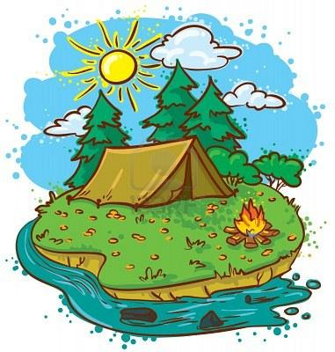

**Overnight Camping Trip**

**\*MUST BE AT LEAST GOING INTO 5TH GRADE TO PARTICIPATE. \***

Friday, July 22nd & Saturday, July 23rd, 2022

Drop off @ Ottaway Park, **7:00 PM Friday, 7/22**

Pick up @ Ottaway Park at **8:00 AM Saturday**, **7/23**

**Cost to Attend**: FREE!

**Location:** Ottaway Park, Route 5, Westfield, NY

**What to Bring**:

* Tent – OR plan to share a tent with someone
* Sleeping bag/blankets, pillows
* Snacks/drinks
* Change of clothes
* Flashlight

*All participants are responsible for keeping track of their own gear, so please pack appropriately. There will be separate boys and girls sleeping areas set up. All field staff will be present for the entire trip. PLEASE ENCOURAGE YOUR CHILD TO NOT BE ON THEIR PHONE THE ENTIRE TIME, AS WE ARE HERE TO ENJOY THE OUTDOORS AND NOT TO SIT AND PLAY ON OUR PHONES*

**Please return permission slips by Thursday, July 21st no later than 5:00 PM as the Field Program will be closed all day on Friday, July 23rd**.

If you have any questions before or during the trip, please contact Andrew Webster at 716-753-6842

------------------------------------------------------------------------------------------------

Please have your child return this portion to attend our Overnight Camping Trip no later than **Thursday, July 21st, 2022,** by 5:00 PM.

**My child:_______________________________**, has my permission to attend the Ottaway Park Overnight Camping Trip on Friday July 22nd/Saturday, July 23rd, 2022. I understand that my child needs to be dropped off and picked up at Ottaway Park. 

**Parent/Guardian Signature:**____________________________ **Date:** ______________

Emergency Contact Person and Phone Number (**REQUIRED**):



Name and Relation to Child Phone #

*PLEASE WRITE DOWN WHO YOUR CHILD WILL BE SHARING A TENT WITH. THANKS!