**2022 Welch Field Summer Recreation Program Permission Slip**

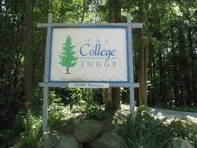

**College Lodge Hiking Field Trip**

Monday, August 8th, 2022

Depart Welch Field @ 12:30 p.m.

Return to Welch Field by 5:00 p.m.

**Cost to Attend**: $10 (bus fee)

**Location:** College Lodge**,** 8067 Route 380, Brocton, NY 14716

**What we are doing:** Going on a hike, playing yard games, and just enjoying nature.

**What to Bring**:

* We will eat lunch before leaving. Kids can either eat the free lunch given out at Welch or bring a packed lunch.
* Sunscreen
* Water
* Appropriate clothing and shoes for hiking
* Bug spray is recommended

*All participants are responsible for carrying their own gear. *

**Please return permission slips by Friday, August 5th no later than 5:00 p.m.** as we need to have our final numbers turned into the bus garage on that day. Children 2nd grade and under, **MUST** be accompanied by a responsible chaperone age 13 or older.

If you have any questions, please contact Andrew Webster at 716-753-6842

------------------------------------------------------------------------------------------------------------

Please have your child return this portion to attend our College Lodge field trip no later than Friday, August 5th by 5:00 p.m.

**My child:** _______________________________, has my permission to attend the College Lodge field trip on Monday, August 8th, 2022.

**Parent/Guardian Signature:**_________________________ **Date:** ________________

Emergency Contact Person and Phone Number (**REQUIRED**):

Name and Relation to Child Phone #