**2022 Welch Field Summer Recreation Program Permission Slip**

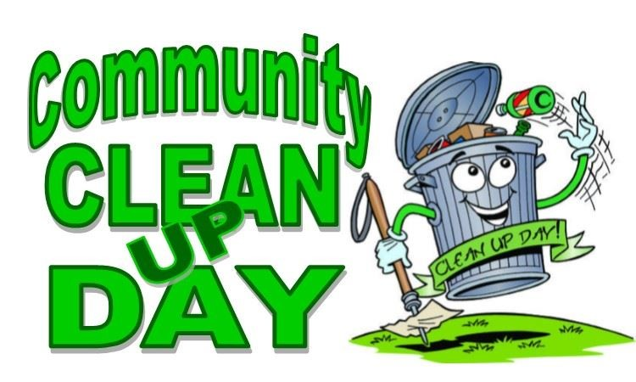

**Community Clean-Up Field Trip**

Thursday, August 11th, 2022

Depart Welch Field @ 2:00 p.m.

Return to Welch Field @ 4:00 p.m.

**Cost to Attend**: $0

**Location:** Parks all over Westfield (including, but not limited to: Moore Park, Smith Field, Northlake Family Rec. Center, Ottaway Park, WACS, etc.)

**What we are doing:** Picking up trash and cleaning our community’s parks.

**What to Bring**:

* We will eat lunch before leaving. Kids can either eat the free lunch given out at Welch or bring a packed lunch.
* Sunscreen
* Water
* Appropriate clothing and shoes for walking and picking up trash.

**Please return permission slips by Wednesday, August 10th, no later than 5:00 p.m.** as we need to have our final numbers turned into the bus garage on that day. Children 2nd grade and under, **MUST** be accompanied by a responsible chaperone age 13 or older.

If you have any questions, please contact Andrew Webster at 716-753-6842

------------------------------------------------------------------------------------------------------------

Please have your child return this portion to attend our community clean-up field trip no later than Wednesday, August 10th by 5:00 p.m.

**My child:** _______________________________, has my permission to attend the College Lodge field trip on Thursday, August 11th, 2022.

**Parent/Guardian Signature:**_________________________ **Date:** ________________

Emergency Contact Person and Phone Number (**REQUIRED**):

Name and Relation to Child Phone #