DRIVE-IN MOVIES AT NORTHLAKE FAMILY REC. CENTER
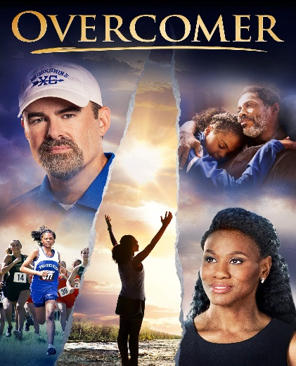
FRIDAY, JULY 17th *Northlake is on Nichols Ave. in Westfield, across the street from Tractor Supply
DRIVE-IN MOVIE RULES
-The parking lot will open at 7:30 p.m. We will have people helping to park vehicles (trucks, vans, SUVS near the back & cars near the front). Please park where you are directed to park. Parking is LIMITED, so get there early. Showtime is just after dusk.
-ALL moviegoers must watch the movie either inside their vehicle, on the tailgate, or directly in front of their vehicle. We encourage everyone to bring their own lawn chairs. No one can sit on top of their vehicle. Every vehicle will have their own spot with plenty of space between them and the next vehicle.
*Sponsored by the -Vehicles MUST turn all their lights and engine off for the durat-
Westfield Ministerial Assoc. ion of the movie. Everyone is encouraged to stay for the whole
movie so that they are not interrupting others. However, if you
FRIDAY, JULY 31st must leave, please do NOT turn on your headlights.

-Northlake is an alcohol, smoke, and pet free environment. No running or horseplay will be allowed in the parking lot. Families can use the many green spaces around Northlake for recreation before the movie, but MUST social distance from people who are not of the same household. Please note that the playground will be CLOSED.

-Admission is FREE, however we are encouraging everyone to donate $5.00 (per vehicle) to Northlake who are a blessing by allowing us to show our movies here.

-There will be NO concession stand. However, people are
*Sponsored by the welcomed to bring their own snacks. Please make sure all
Westfield Recreation Dept. garbage is thrown out.

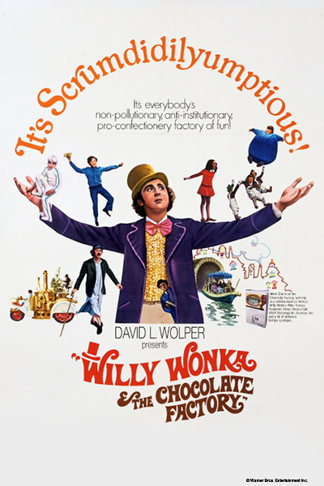
FRIDAY, AUGUST 14th -Northlake’s bathrooms will be CLOSED. However, we will have a
portable restroom available.

-We will have multiple speakers plugged in to broadcast the sound of the movie. However, we will also have an FM radio connection. So, we encourage people to bring a portable radio so that they do not risk their car battery dying.

-Please do NOT come to the drive-in movies if you are feeling sick. All moviegoers MUST stay at least 6 feet away from people not of the same household. We encourage everyone to bring hand sanitizer for their vehicle to use.

-Once again, parking is LIMITED, so please get there at 7:30 p.m.
*Sponsored by the or shortly thereafter to make sure that you can get a spot.
Westfield Recreation Dept.
-We look forward to sharing this unique movie going experience with all of you! See you at the drive-in!!

