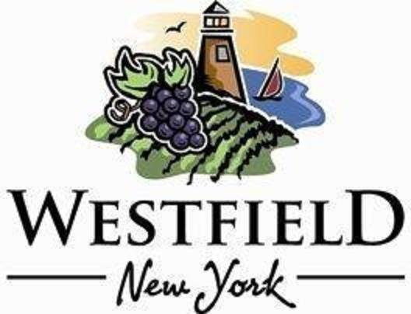

AGENDA
VILLAGE OF WESTFIELD
PLANNING BOARD

DATE: Wednesday, January 10th, 2024 PLACE: Eason Hall -North Room
TIME: 7:30am

- 7:30 AM: Open public hearing/take comments from the public for 50-60 Franklin Street (Kaleidoscope Farms) Special Use Permit

- 7:45 AM: Open public hearing/take comments for 37 East Pearl Street ( Blake & Kim Maras) Special Use Permit

- Close public hearing for 50-60 Franklin Street

- Action on 50-60 Frankling Street

- Close public hearing for 37 East Pearl Street

- Action on 37 East Pearl Street

IV. Minutes review and approval -December 13, 2023, Planning Board Meeting

V. Adjournment

