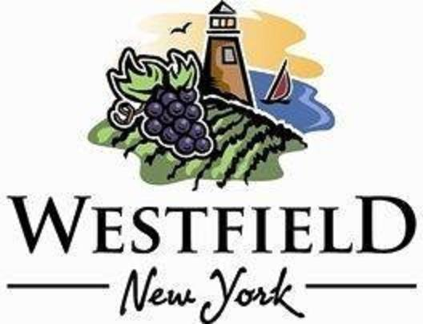

AGENDA
VILLAGE OF WESTFIELD
PLANNING BOARD

DATE: Tuesday, July 8th, 2025 PLACE: Eason Hall -North Room
TIME: 4:00 pm

- 70 E. Main St., Community Bank LED Sign

2. 39 Union Street Fence -Orina McGrew

- June 10th, 2025 Meeting Minutes Review/Approval

- Adjournment

